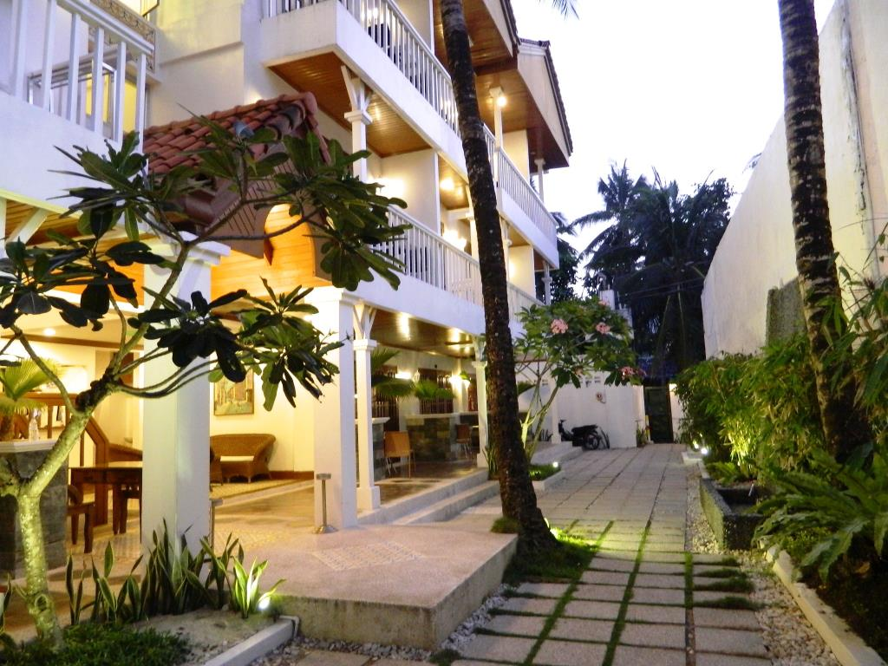

Hey Jude Resort Hotel Boracay

WEBSITE: https://www.heyjude-boracay.com/?utm_source=GooglePlusLocal&utm_medium=Local&utm_campaign=GooglePlusInitiative

<https://www.facebook.com/pages/category/Hotel-Resort/Hey-Jude-Resort-Hotel-164515006898719/>

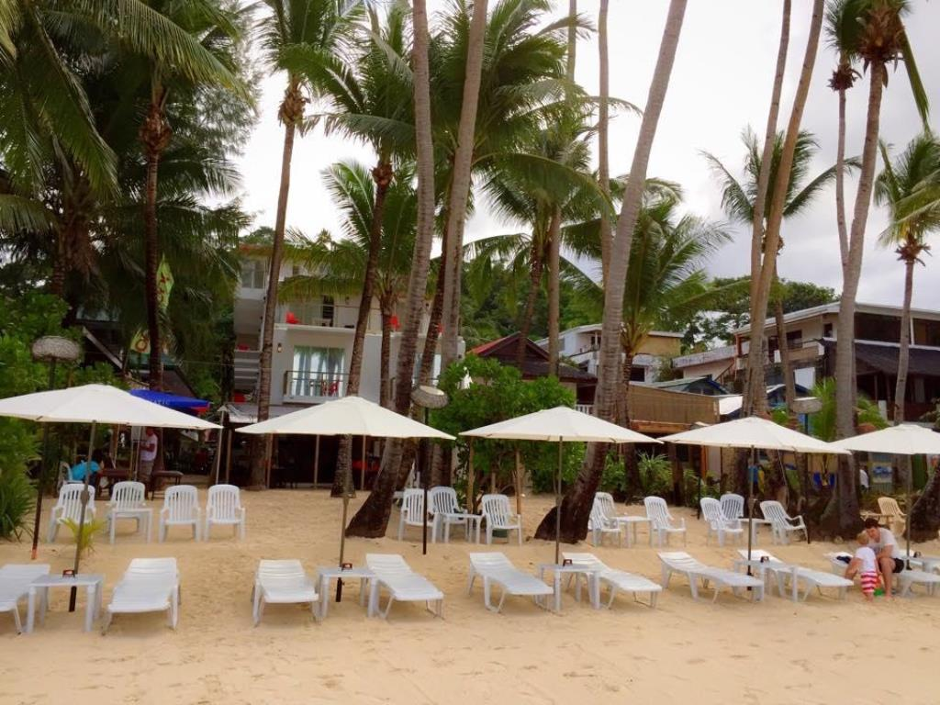

HEY JUDE SOUTH BEACH RESORT

WEBSITE: <https://www.facebook.com/heyjudesouthbeach/>

https://www.agoda.com/hey-jude-south-beach-resort/hotel/boracay-island-ph.html?cid=-187

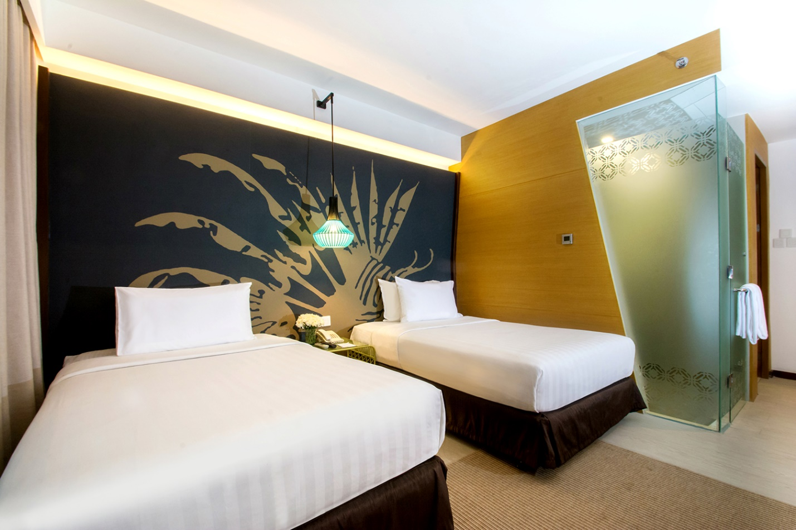

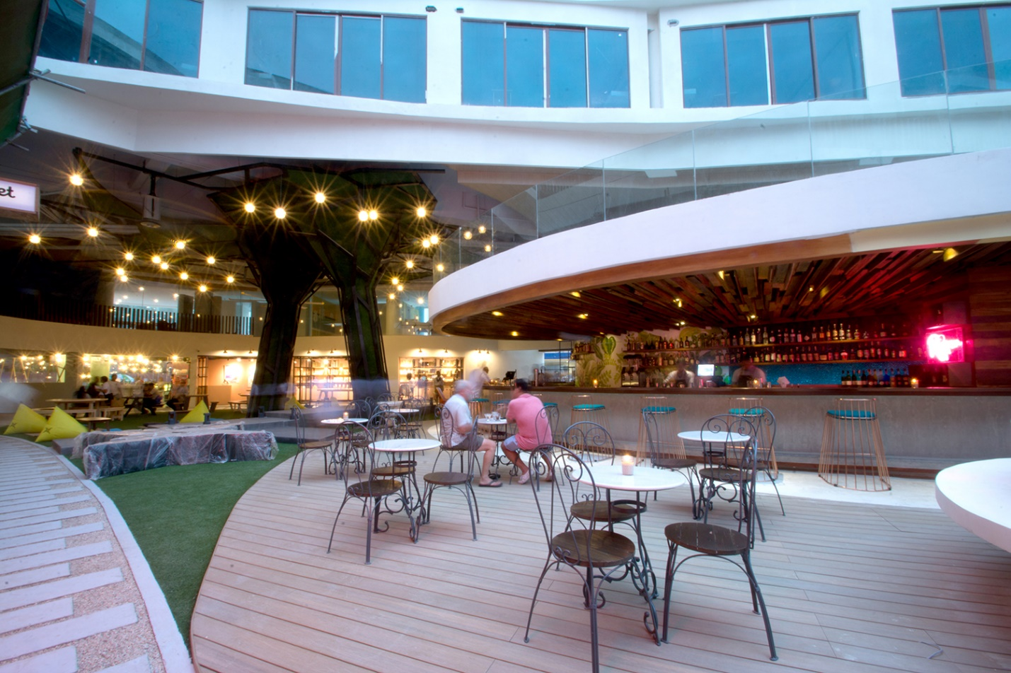

HUE HOTELS & RESORT BORACAY

WEBSITE: <https://thehuehotel.com/boracay/about-us/>

https://thehuehotel.com/boracay/wp-content/uploads/DSC_4264.jpg

https://thehuehotel.com/boracay/wp-content/uploads/DSC_4365.jpg

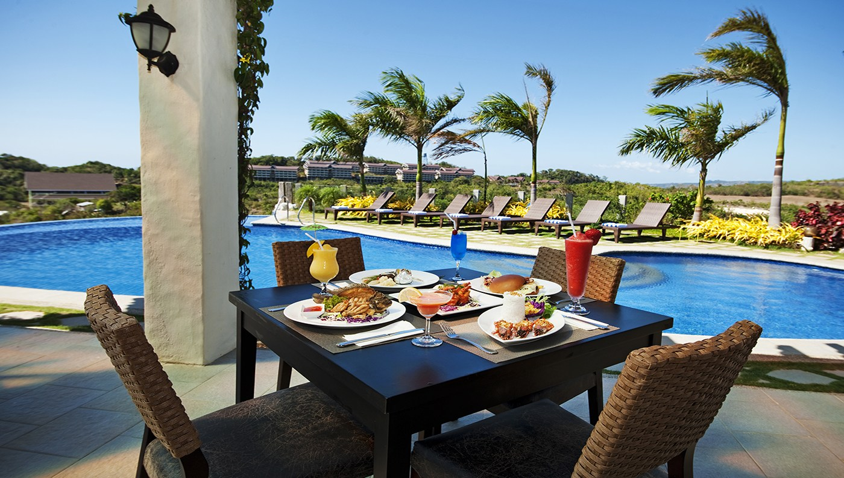

HOTEL SOFFIA BORACAY

WEBSITE: <https://hotelsoffia.com/>

<https://i2.wp.com/hotelsoffia.com/wp-content/uploads/2016/10/Hotel-Soffia-Boracay-Coffee-Shop-1-1.jpg?ssl=1>

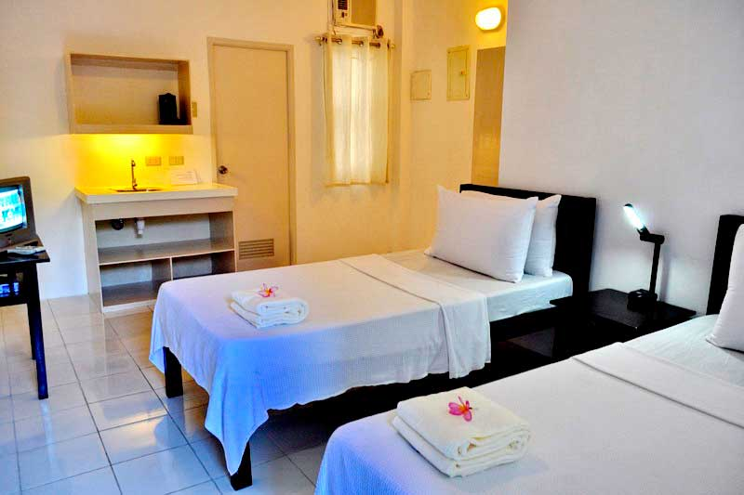

AZUL BORACAY

WEBSITE: <http://azulboracay.com/>

https://www.google.com.ph/url?sa=i&source=images&cd=&cad=rja&uact=8&ved=2ahUKEwit-bOTrI_eAhUKN48KHV-JAO4QjRx6BAgBEAU&url=http%3A%2F%2Fwww.myboracayguide.com%2Frooms%2Fboracay-hotel-Azul-Boracay-176&psig=AOvVaw2uhad7y40IrGIlrEvhtAna&ust=1539929925310555

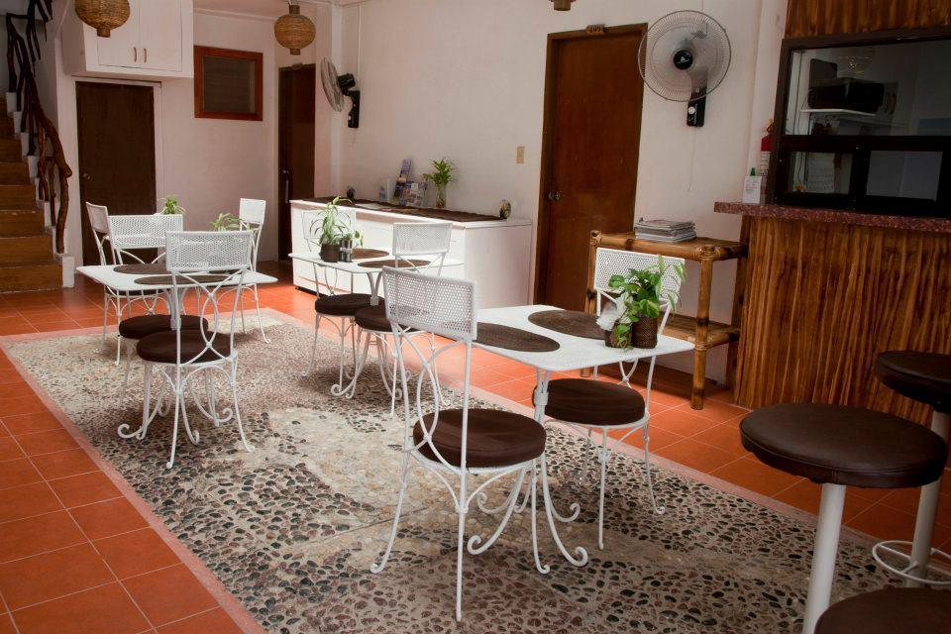

ISLA GECKO RESORT

WEBSITE: <http://www.islagecko.com/>

https://t-ec.bstatic.com/images/hotel/max400/885/8852424.jpg

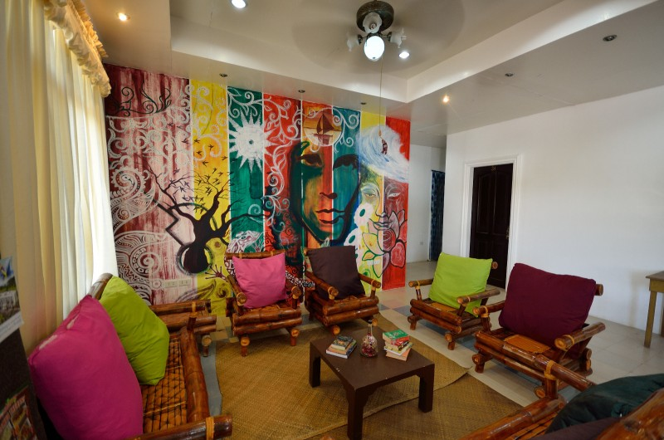

ISLAND INN

WEBSITE: <http://www.islandinnboracay.com/>

http://new-hls.s3.amazonaws.com/hls/data/570/gallery/thumbs/full_dsc_3542_1435905855.jpg

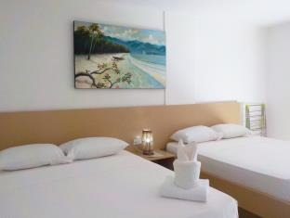

JEFFREY S HOTEL

WEBSITE:

http://boracaybeachhotel.com/goto/_/11415/1

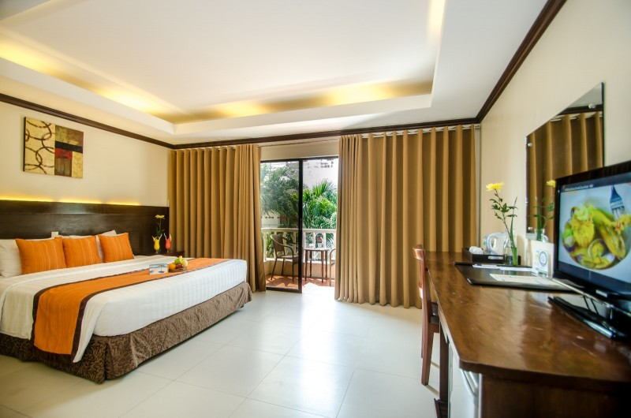

JONY’S BEACH RESORT

Website: <https://www.jonysbeachresortboracay.com/en/>

<https://www.jonysbeachresortboracay.com/photo>

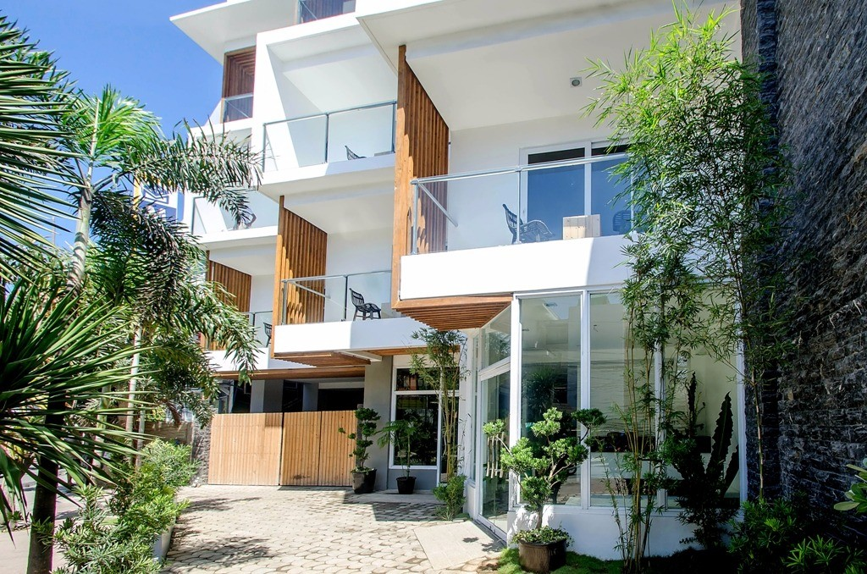

JONY’S BOUTIQUE HOTEL

WEBSITE: http://www.jonysboutiquehotel.com/

<http://new-hls.s3.amazonaws.com/hls/data/1743/gallery/thumbs/full_facade--3-_1458029082.2_1458029082.jpg>

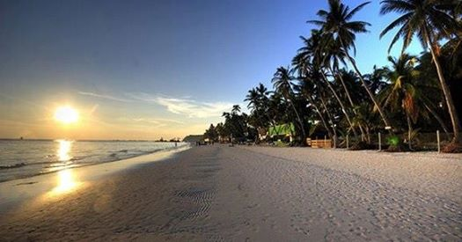

LADY JEAN RESORT

WEBSITE: https://www.facebook.com/Ladyjeanresort/?__tn__=HHH-R

<https://scontent.fceb1-1.fna.fbcdn.net/v/t1.0-0/c0.22.525.275/p526x296/13007372_1591564044490448_7029906232747425408_n.jpg?_nc_cat=104&oh=0fc35f309c7cffe967ccf557aade918b&oe=5C491034>

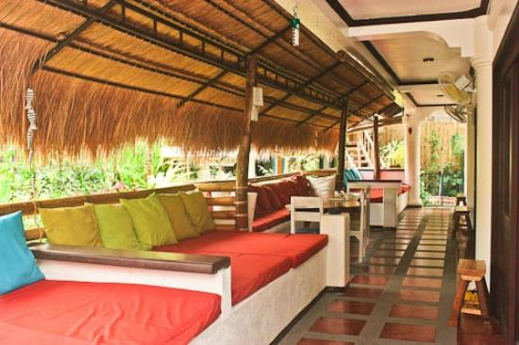

LANTERNA MINI HOTEL

WEBSITE: http://lanterna-mini-hotel.hotelsboracay.org/en/#photo

<https://www.google.com.ph/url?sa=i&source=images&cd=&cad=rja&uact=8&ved=2ahUKEwi9jIi-so_eAhXFdn0KHWjyB2gQjRx6BAgBEAU&url=https%3A%2F%2Fwww.tripadvisor.com.ph%2FHotel_Review-g294260-d7848665-Reviews-Lanterna_Hotel-Boracay_Malay_Aklan_Province_Panay_Island_Visayas.html&psig=AOvVaw2qr-tHSnz7ROSUIendtWHC&ust=1539931608698744>

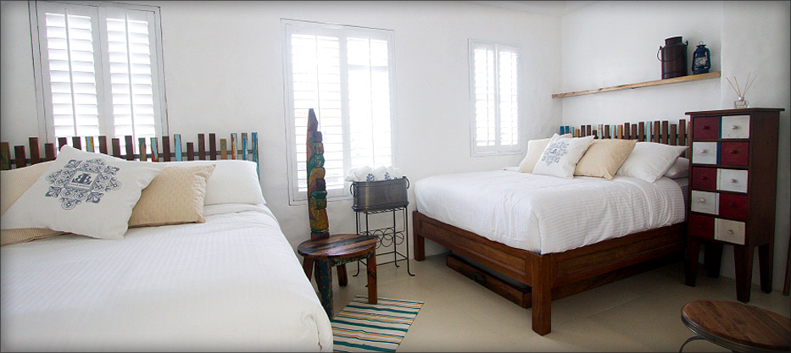

LUGAR BONITO HOTEL

WEBSITE: <http://www.lugarbonitohotel.com/>

http://www.lugarbonitohotel.com/wp-content/uploads/2014/11/pcs-1.jpg